Denver, South Park & Pacific Cooke Mogul Project

This is a test for importing a Word document.

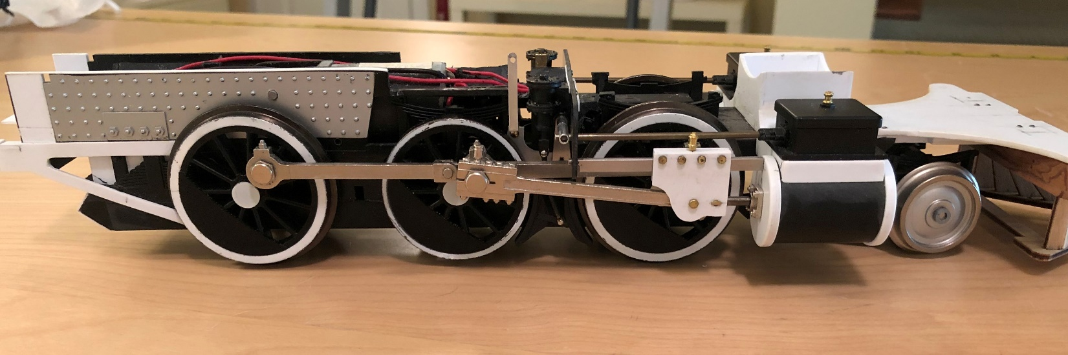

End of test.

